Project Design Phase-II
Data Flow Diagram & User Stories
Date | 01-10-2026 | Team ID | SWTID-2026-5415
Project Name | Import Data Using Transform Maps (Spreadsheet) | Maximum Marks | 4 Marks
Data Flow Diagrams show how spreadsheet data enters ServiceNow, is transformed, stored and related to employee information.
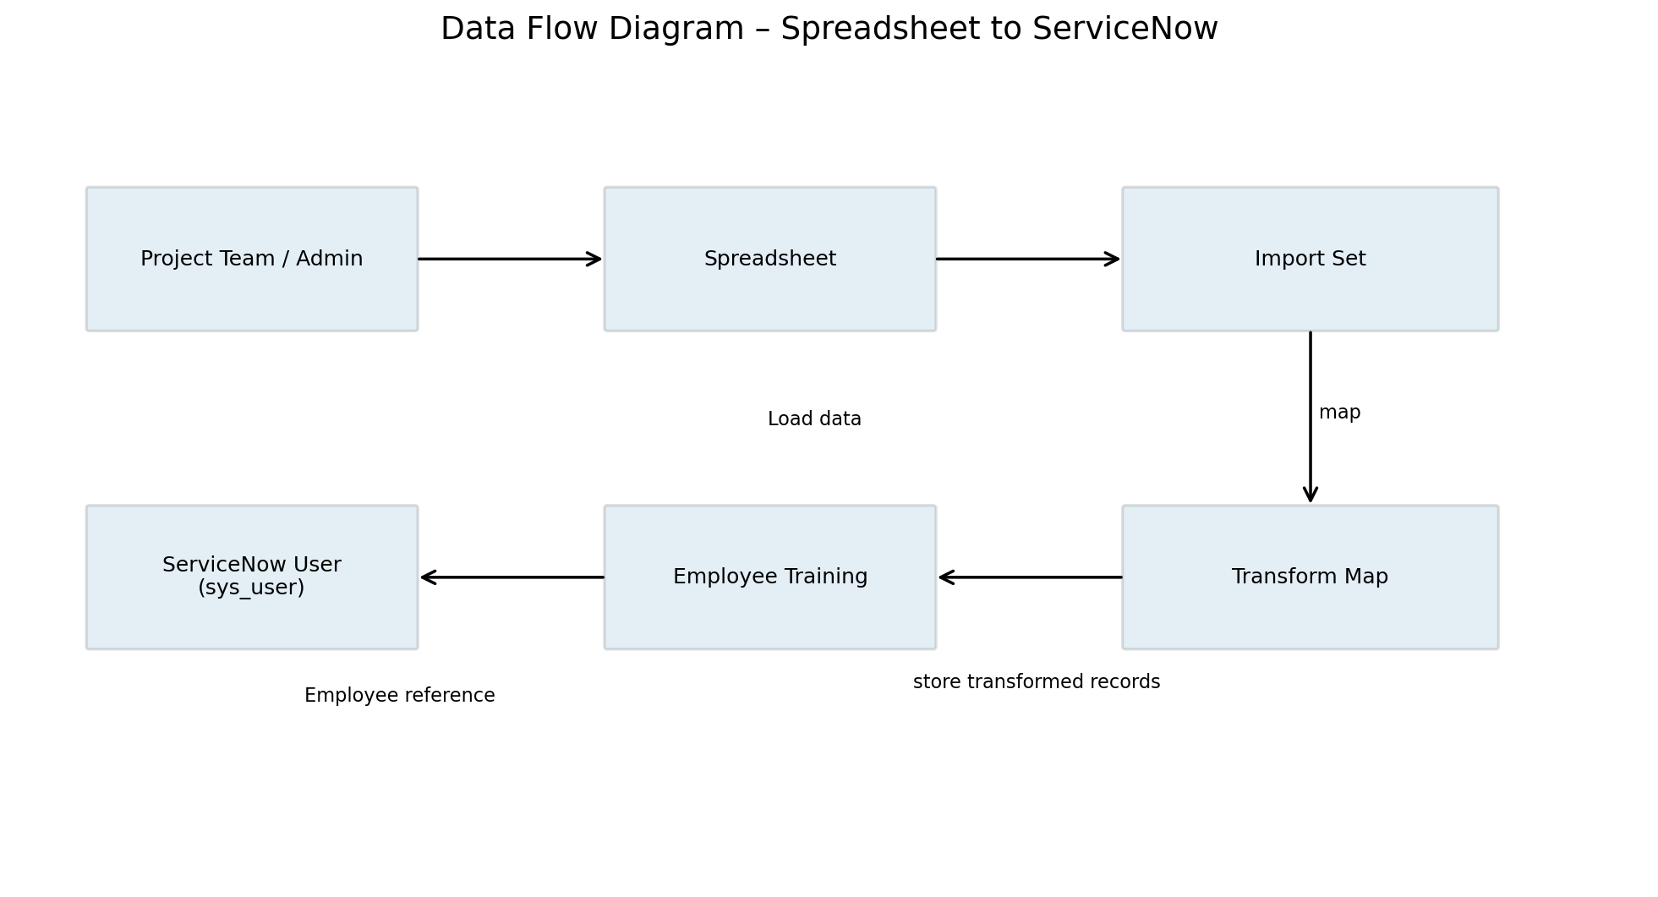

User Stories
User Type | Functional Requirement (Epic) | User Story Number | User Story / Task | Acceptance criteria | Priority | Release
Administrator | Import | USN-1 | As an administrator, I can load the project spreadsheet using Import Sets. | Source data is loaded into the import process. | High | Sprint-1
Administrator | Transform | USN-2 | As an administrator, I can map source fields to target fields using a Transform Map. | Mapped fields populate the target records. | High | Sprint-1
Authorized User | Relationship | USN-3 | As an authorized user, I can associate the record with an Employee. | Employee reference is available. | High | Sprint-2
Authorized User | Security | USN-4 | As an authorized user, I can access records according to role and ACL rules. | Read/Write access follows configuration. | High | Sprint-2

